ENGR101 Assignment 4

#### Name: Niels Clayton Student ID: 300437590

**Core 1:**

2^10 = 1024

**Core 2:**

5/1025 = 5 millivolts

**Core 3:**

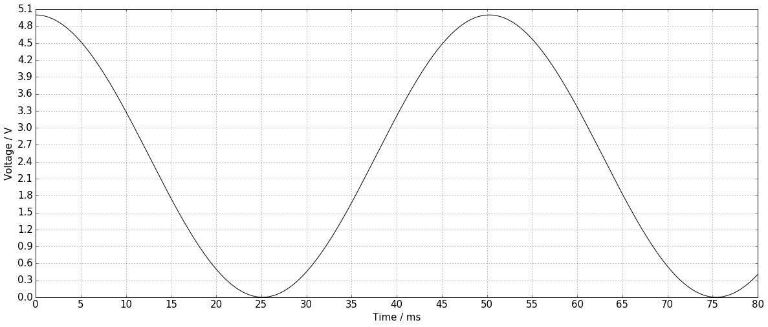

**Step width (sampling period):** 5milliseconds

**Step height (4-bit ADC resolution):** 0.3333 or 1/3

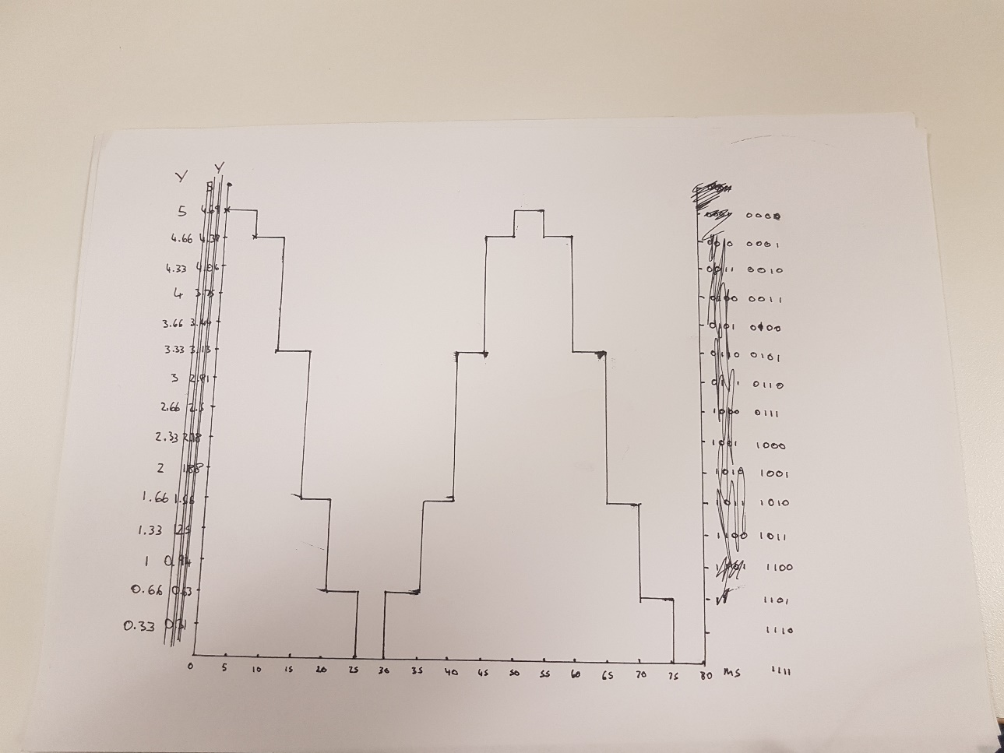

**Core 4:**

One full wavelength ever 50ms, meaning the wave has frequency of 20Hz

**Core 5:**

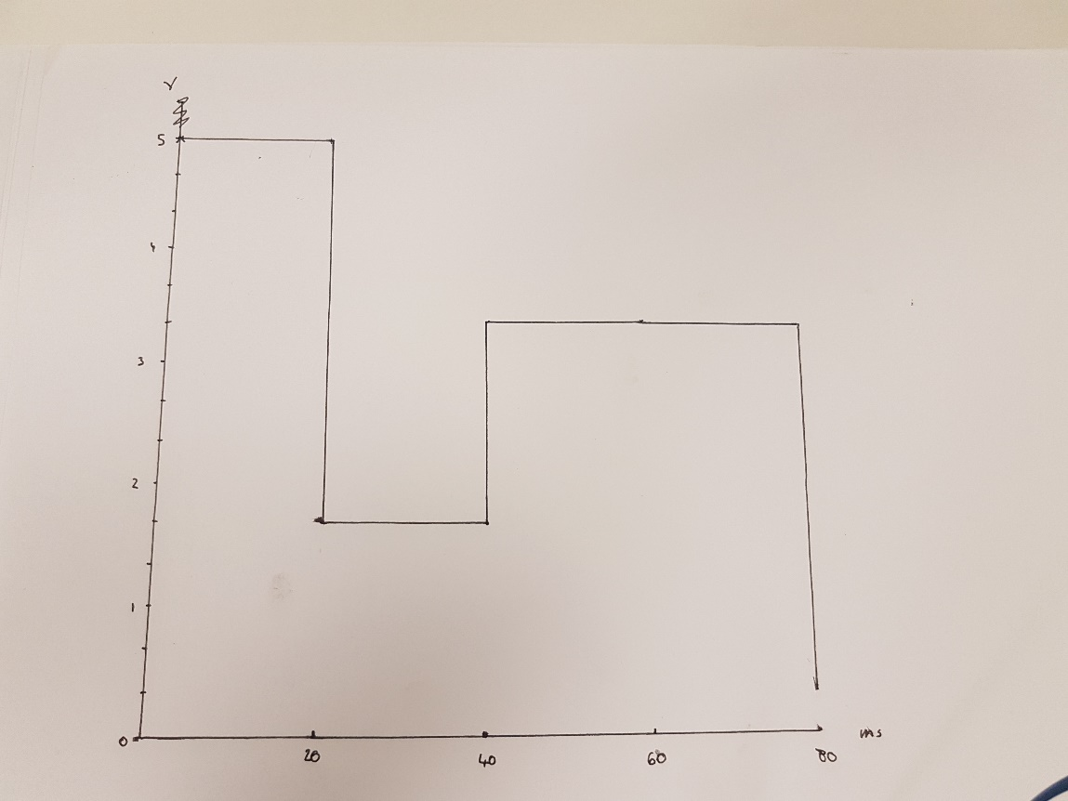

**Completion 1:**

The sampling rate of a wave must be at least 2 times the frequency of the wave to get accurate readings. This is because if the sample rate is either the exact frequency you have the chance to read exactly the same position on the wave every time, making it seem static. And if the sample rate is less than the frequency you will completely miss features of the curve such as peaks.

**Challenge 1:**

Humans can hear between 20 – 20,000 Hz, this means that using Nyquist Sampling theorem we should sample at above 40,000, the greater above 40,000 the more accurate the readings will be. The standard sample rate of an MP3 file is 40,100 samples per second, this complies with the theorem as it is above 40,000 samples per second.

**Core 6:**

|  |  |  |  |
| --- | --- | --- | --- |
| Figure | Signal amplitude | Noise amplitude | SNR |
| **4** | 5v | 0.25v | 100 |
| **5** | 5v | 0.75v | 33.333 |
| **6** | 5v | 5v | 1:1 |

**Core 7:**

The greater the signal to noise ratio, the smaller the noise amplitude is when compared to the wave amplitude. This means that the higher the STN ratio, the smaller the effect of the noise on the signal when doing an analogue to digital conversion.

**Core 8:**

#include <stdio.h>

#include <time.h>

#include "E101.h"

int main()

{

init();

int adc_reading;

int adc_reading2;

adc_reading = read_analog(0);

sleep1(0,100000);

adc_reading2 = read_analog(2);

printf("%d\n", adc_reading);

printf("%d\n", adc_reading2);

return 0;

}

Readings:

A0 = 11

A2 = 1

**Completion 2:**

Because the Pi is not properly grounded it is picking up a voltage due to static or possibly electromagnetic interference from the analog inputs without sensors.

**Core 9:**

#include <stdio.h>

#include <time.h>

#include "E101.h"

int main()

{

init();

int adc_reading;

int max_reading=0;

for(int i=0; i<10; i=i+1)

{

adc_reading = read_analog(0);

printf("%d\n", adc_reading);

sleep1(1,100000);

if(adc_reading>max_reading)

{max_reading = adc_reading;};

}

printf("The max is: %d\n", max_reading);

return 0;

}

*Maximum value: 537*

**Completion 3:**

Maximum value: 708

Minimum value: 4

Comparison against Core 1 and Core 2 answers: <your answer here>

#include <stdio.h>

#include <time.h>

#include "E101.h"

int main()

{

init();

int adc_reading;

int max_reading=0;

int min_reading=1023;

for(int i=0; i<50; i=i+1)

{

adc_reading = read_analog(0);

printf("%d\n", adc_reading);

sleep1(1,10000);

if(adc_reading>max_reading)

{max_reading = adc_reading;};

if(adc_reading<min_reading)

{min_reading=adc_reading;};

}

printf("The max is: %d\n", max_reading);

printf("The min is: %d\n", min_reading);

return 0;

}

**Core 10:**

Mean value: 248

#include <stdio.h>

#include <time.h>

#include "E101.h"

int main()

{

init();

int adc_reading;

int total=0;

for(int i=0; i<5; i=i+1)

{

adc_reading = read_analog(0);

printf("%d\n", adc_reading);

sleep1(1,100000);

total= total+adc_reading;

}

int average=total/5;

printf("The average is: %d\n", average);

return 0;

}

**Completion 4:**

Half-range value: 277

#include <stdio.h>

#include <time.h>

#include "E101.h"

int main()

{

init();

int adc_reading;

int total=0;

int max_reading=0;

int min_reading=1023;

for(int i=0; i<5; i=i+1)

{

adc_reading = read_analog(0);

printf("%d\n", adc_reading);

sleep1(1,100000);

total= total+adc_reading;

if(adc_reading>max_reading)

{max_reading = adc_reading;};

if(adc_reading<min_reading)

{min_reading=adc_reading;};

}

int average=total/5;

int half_range=((max_reading-min_reading)/2);

printf("The average is: %d\n", average);

printf("The half range is: %d\n", half_range);

return 0;

}

**Challenge 2:**

Ways to reduce noise:

Hardware – insulate the wires so that less electromagnetic signals (from the air) are picked up by the wires, as ideally all the voltage signal should come from the sensor. Also, by keeping the circuit board cool and reducing the heat, the noise can be reduced too.

**Challenge 3 (Bonus marks only):**